**Scenario 1:**

The College of Engineering, IT and Environment (CEITE) at CDU has been using file sharing in the past. CDU IT department has advised that all Colleges in CDU will have to create a SharePoint site for their own College and move their files to across. CEITE is made of 3 disciplines, Engineering, IT and Environment. The College also has an administration team that supports all the disciplines in day-to-day activities and other areas such as finance, marketing, and events.

You have been tasked to design and create a SharePoint site for the College. You know that some Engineering and IT units are part of multiple courses across the 2 disciplines, but Environment does not overlap with other disciplines. Your manager has told you that the documents each discipline has are lecture slides, tutorials, course flyers and marketing material, exams, instruction videos and student’s lists. You have also learned that each discipline wants to move their research data to SharePoint, but not share it with other discipline members. Explain in (x-x number of words) how you would design the site and give a reason on why you designed the site this way. Create the site hierarchy and permission groups. Show screenshots of the permission groups and site hierarchy. Explain how permission groups are assigned to different libraries, sites or folders (depending how you created the site).

**Notes :**

* The total word count ~ 900 to 1100 words and approx. ~300 words /student. Make it more readable.
* This is a group assignment and your group will be submitting only one report.
* If you have any questions, post it in the discussion board and it will be answered within 2 working days.
* A group of upto 3 people can be formed for Assignment 1 and 2 before week 3 class.
* You cannot change the group in between semester.
* Refer to marking rubrics in the learnline.

SharePoint Site Overview

* Site will have three main areas: Environment, IT and Engineering
* Site will also contain and administration area.
* Home page will show news/announcements and divert attention to the 3 main pages.
* Documents will be tagged with meta data to provide access to appropriate individuals or groups.
* Users will be allocated access based on their discipline.

**Role-based access control**

Students, faculty and staff have various levels of access to ensure that the correct people are accessing and/or editing the correct files and pages.

The group Admin Owners is used for the assignment purposes, as well as the group that would be used as an IT support group, while Administrative Staff will be for staff to access, edit and modify documents, pages and access levels. Each of the Faculty groups will have access to edit, and delete documents and other files, whilst Student groups will only be able to read others posts and edit their own.

Within each specialisation, students and faculty will only be able to access the information of the faculty that they belong to. This prevents potential for students from uploading to the incorrect library and staff from deleting from others’ libraries.

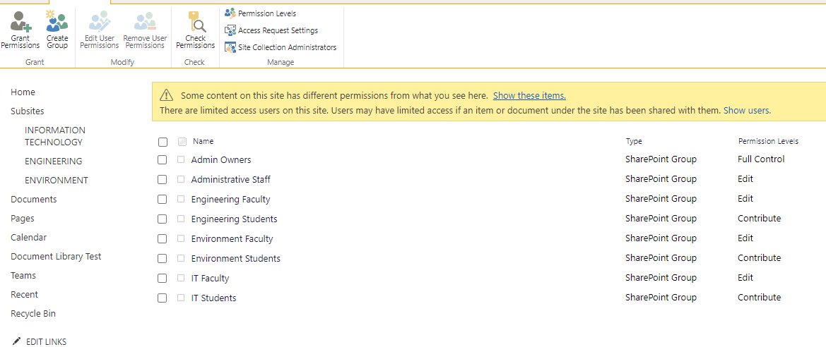

This image demonstrates that within the Research Library in the IT page, only IT Faculty and Admin Owners have access. There is an option to create an additional group, IT Research Students, however was not done for this exercise. Some Research students may also be Faculty therefore will be added to their respective faculty groups.

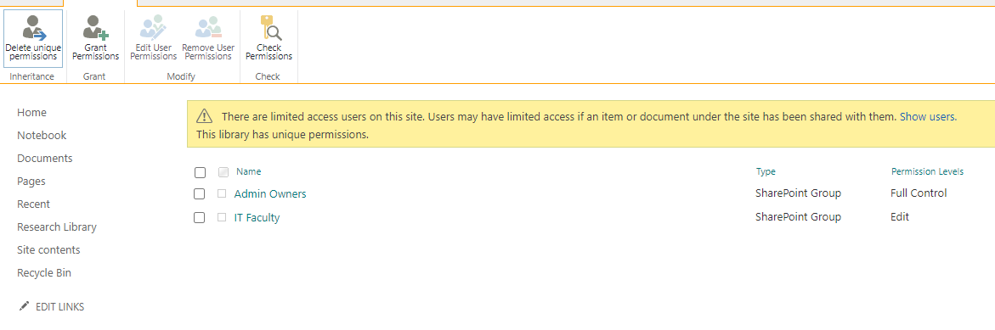

As seen here, an Engineering student only has access and visibility of the Engineering page and not the Research Library. Where a student is required to have access to both Engineering and IT pages and documents, the individual will be added to both groups.

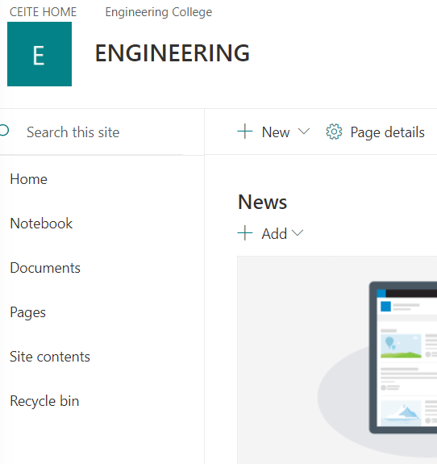

**Document Sharing**

Document sharing is a difficult issue to consider and solve. Options considered were to input metadata for each file to be shared, however this was considered to be too technically difficult for all staff and students.

Use of Share Folders. This option uses a designated folder for adding documents that are to be shared within the College. This folder allows staff and students to upload files to a common location, within their specialty, then those files will be shared across the College without need to add or remove any other information.

This will be made more user friendly, by removing the folders from view in default, therefore, users will be able to view all files without the need to enter folders.

SWOT analysis

Other integrated programs

Teams

* Default groups will be assigned based on discipline and/or position (admin will either be personnel from the admin team or within the faculty)
* All users will be able to create and manage their own teams